Monday 18th of May
See Today’s Welcome Video on Seesaw
Word families: This week instead of Look, Say, Cover Write, Check we will be revising ‘Word Families.’ Word families have the same sequence of letters at the end so they rhyme. Today we will look at the -ill word family. Look at the pictures below and write a list of the words that you see. Remember they all end in -ill. Tomorrow your task will be to write the words without the pictures so make sure you really focus your brain on the pictures that you see and the words that you write.
 | 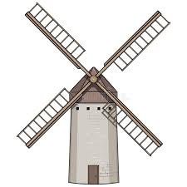
 | The flowers are on the window…. | Can you write some other words that are in the -ill word family?

Story: The Cat in the Hat by Dr Seuss. Click on the link below and enjoy hearing this story with lots of rhyming words.The story is over nine minutes long so if it suits you better listen to half today and half tomorrow. As a challenge you can mute the video and read some of the story yourself.
https://www.youtube.com/watch?v=gpRYk6Q4TmQ
Tasks based on the first half of the story: 1. Pause the video at 1 minute 6 seconds. Write a list of all the words that you see that rhyme with fat.
2. Pause the video at 2 minutes 4 seconds. How do you think the fish feels?
3. Pause the video at 2 minutes 40 seconds. Look at the picture, write a list of all the things that the cat is holding.
4. The cat ran fast as a ………...

Gaeilge: Watch the video of Sinead and Podge on Seesaw.
Podge is asking Sinead the question ‘Cad ata ort?’
Sinead is answering with the sentence ‘Ta _____orm.
After watching the video, ask your child ‘Cad ata ort?’ and encourage them to describe what they are wearing to you.
Send an audio clip or video of your child trying this activity on Seesaw.
Maths: Your Maths activities for today are on Seesaw. You will be learning about number order, creating and using a number line to count forwards and backwards, and using a number line to help you to combine two numbers.
Mother Language Fortnight:
What are you thankful for today?

